Summary Report  
Nonlinear Adaptive Pulse Coded Modulation – Based Compression（NADPCMC）

**Lu Baohui、Wei Lai、Pan Mengyang、Zhang Yaoyuan**

**Ⅰ. Description of scenarios & Performance metrics**

* 1. **Description of scenarios**

By establishing a nonlinear NDPCM dynamic prediction model, the next sample value is predicted, the error between the actual sample value and the predicted value is compressed and transmitted, and the receiving end reconstructs the sample value based on the transmitted error and the known prediction model to reduce communication overhead.

* 1. **Performance metrics :**

• Average error: The average error between the reconstructed sampled values and the original sampled values, used to evaluate the accuracy of the reconstruction.

• Number of bits transmitted: Used to evaluate the communication overhead, which is the number of bits occupied by the error data sent, controlled by adjusting the parameters of the compression algorithm (such as n_bits).

• Stability: Control the stability of the prediction model through the alpha parameter to prevent the prediction model from diverging or being unstable.

**Ⅱ. Discussion of results**

**2.1 Vary number of bits for encoding**

When $α=e^{−5 }$, the change of reconstruction error is shown in the figure below：

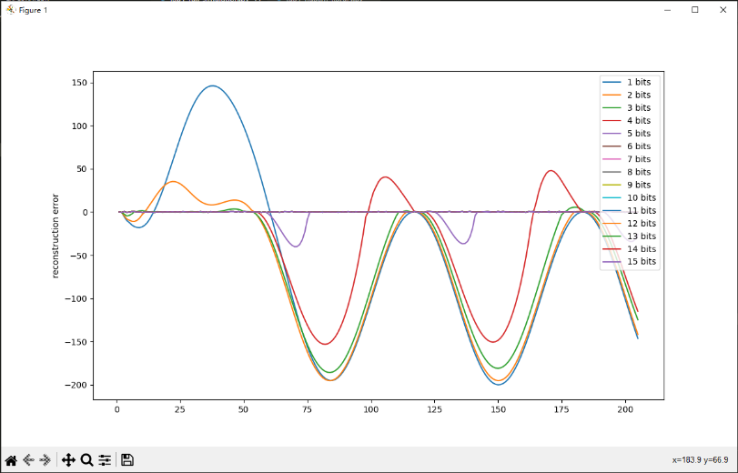

It can be seen from the image that when $n>6 bit$, the reconstruction error is between（-0.5，0.5）, as shown in the following figure:

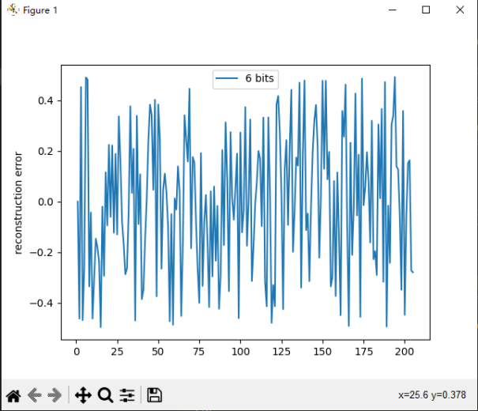

Since the range of f in the code is 0-200, when $n≥\log_{2}{200}$， $\log_{2}{200}$ is rounded down, that is, $n>6 bit$, the reconstruction requirements can be basically met. When $n<\log_{2}{（max_f−min_f）}$， $\log_{2}{（max_f−min_f）}$ round down, at this time the reconstruction error should start to increase significantly, that is, for $n=5 bit$ in this example:

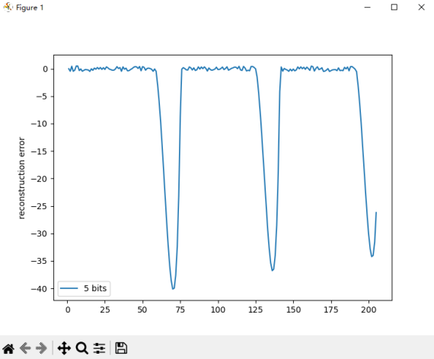

The reconstruction error range is (-50,1), that is, when n<=5 , the reconstructed singal error became significantly larger.

**2.2 Vary the value of α and Kv gain**

From 2.1, $max_y=200$, $h_depth=3$, according to the formula：

$$max_α=\frac{1}{h_depth×{(max_y)}^{2}}$$

Can be obtained $max_α=8.333816166615037e^{−0.6}$. In the same way, according to the formula $$max_K_{v}=\sqrt{1−α×h_depth×{(max_y)}^{2}}$$ 
Can be obtained $max_K_{v}=0.9380868575971175$.

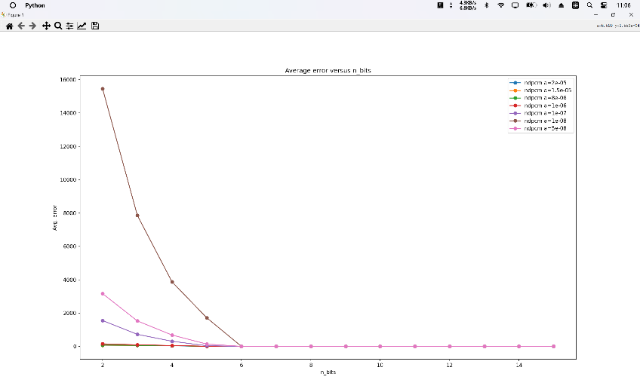

As can be seen from the figure, as $n_bits$ increases, the average error generally decreases. This is because more digits provide greater precision. However, when $n_bits$ reaches a certain value, increasing $n_bits$ will not significantly reduce the error. In addition, the choice of α value and $K_{v}$ gain will also affect the error. Larger $K_{v}$ values can provide higher accuracy, but also lead to reduced system stability. Therefore, a balance needs to be found between accuracy and stability.

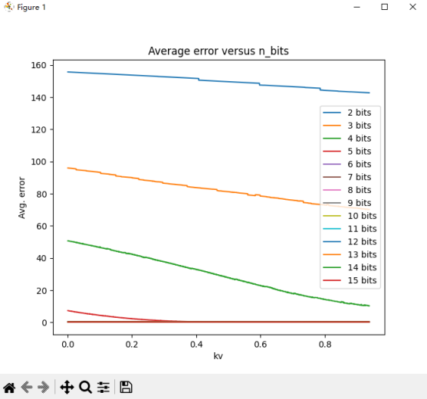

It is found from the above figure that as $n_bits$ increases, the average error does show a downward trend. For different $K_{v}$ values, the average error changes in the same trend. Bigger $K_{v}$ values result in smaller average errors. Therefore, let $K_{v}=max_K_{v}$.

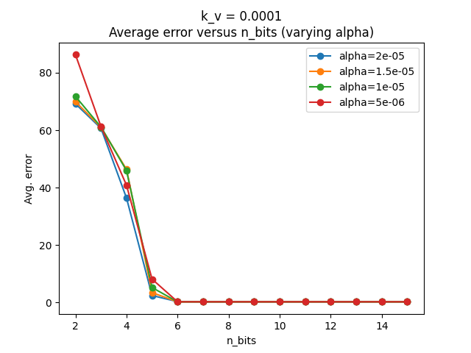

As α decreases, the average error for most $n_bits$ values increases. Therefore, larger α values usually lead to better performance in terms of error.

We find the best alpha and $K_{v}$ values ​​through experiments as follows:

$$K_{v}=0.0001$$

**Ⅲ. Conclusions and Lessons Learned**

The code generation results before modifying the formula are as follows.  
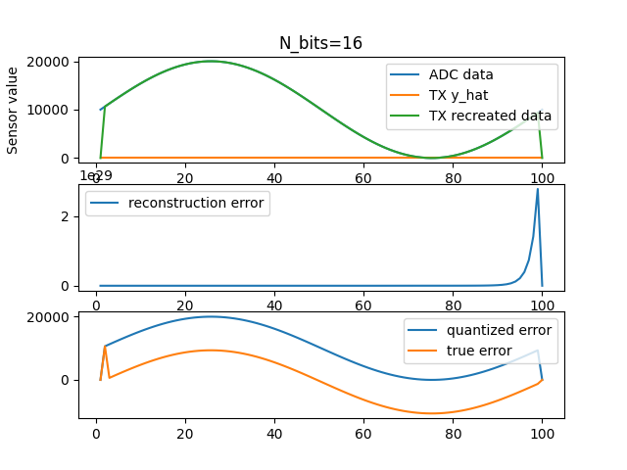

Considering that when i=k, eq(k-1) has not been updated to eq(k), we modify the update  
formula of $\hat{θ}\left(k\right)$ $$\hat{θ}\left(k\right)=\hat{θ}\left(k−1\right)+αφ\left(k−1\right)e_{q}(k)$$ 
to calculate $\hat{θ}\left(k\right)$ using eq(k-1). The modified formula is as follows: $$\hat{θ}\left(k\right)=\hat{θ}\left(k−1\right)+αφ\left(k−1\right)e_{q}(k−1)$$ 
The modified code output is shown in the figure below. The recreated signal is very close to the predicted signal.

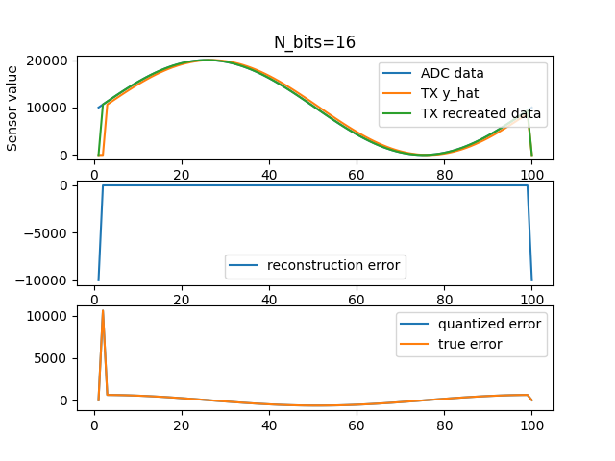

This shows that the modified formula makes the model fitting error smaller and the reconstruction effect is better.

Lesson learned: In the process of completing our exercises, we should experiment multiple times to find general patterns, to prevent special cases from becoming conclusions.